**Lab 6: Practice Exercise**

1. Go to the Blackboard site for your section (not the metasite) and download the files: Lab6.m and Lab6.fig. Save them in your current MATLAB folder.

**Important: Make sure the files names are Lab6.m and Lab6.fig. If not, rename them. Also make sure they appear in your current MATLAB folder.**

1. At the command prompt, type Lab6. You should see the GUI shown in Figure 1. You can click on the menu, write stuff in the two edit boxes, and push the Clear button but nothing happens.

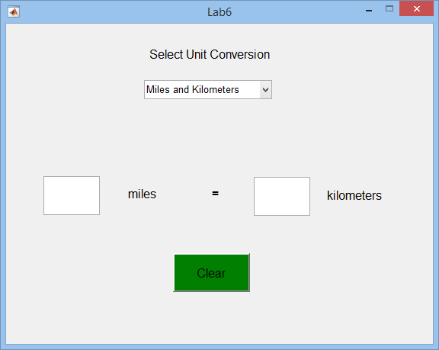

Tag for PushButton:

Button

Tag for Edit Box:

Value2

Tag for Static Text Box:

Unit2

Tag for Static Text Box:

Unit1

Tag for Edit Box:

Value1

Tag for Menu:

UnitMenu

**Figure 1: Unit Conversion GUI**

1. Your job is to add the code to make this GUI functional. Notice that the tags for each component are listed in Figure 1. ***Make sure you do not re-use the tag names for other variables in your code.*** The tag names are used to refer to the components in the GUI.
2. Open the Lab6.m file.
3. Add code to make the popupmenu (tagged UnitMenu) do the following:

* Get the user’s choice for unit conversion (get command)
* Write the units chosen into the two static textboxes (set commands)
* Clear the two edit text boxes (set commands)

1. Test the menu to make sure it works correctly. Write stuff in the edit boxes to make sure the contents actually clear when the user selects a set of units.
2. Add code to make the pushbutton (tagged Button) clear the contents of the two edit boxes. Then test to make sure this feature works correctly.
3. Add code to make the edit box on the left (tagged Value1) do the following:

* Get the user’s choice for unit conversion
* Get the contents of the edit box and convert it to a double
* Check to see if the contents of the box really is a numerical value. If it is not a number, clear the contents and send a message to the user that a number must be entered. Otherwise, fill in the other edit box (tagged Value2) with the correct number.

1. Check to make sure the edit box on the left works correctly. Try entering text. Do you get an error message? Then test both sets of units and make sure the correct values appear in the edit box on the right (i.e., the unit conversion calculation is done correctly).
2. Repeat Steps 8 and 9 for the edit box on the right (tagged Value2).
3. When completed, demonstrate your working GUI to your T.A. The lab will be graded by your T.A. as follows:

**FirstGUI (Created During the Tutorial):** **50 Points**

* Built the GUI using guide **(10 pts)**
* When the GUI opens, there are graphs and values in the boxes **(10 pts)**
* Popup menu works **(10 pts)**
* Edit box works to change the frequency of the sin wave in the top plot **(10 pts)**
* The slider works to change the amplitude of the sin wave in the top plot **(10 pts)**

**Lab6 GUI (Lab Exercise):** **50 Points**

* Menu: writes choice of units into the static text boxes **(10 pts)**
* Menu: clears the edit boxes **(5 pts)**
* Pushbutton clears the edit boxes **(5 pts)**
* Left Edit Box: produces error message for entering text and clears the box **(5 pts)**
* Left Edit Box: performs selected conversion and writes correct value in the right box **(10 pts)**
* Right Edit Box: poduces error message for entering text and clears the box **(5 pts)**
* Right Edit Box: performs selected conversion and writes correct value in the left box **(10 pts)**